**Interactive Debugger**

This [Python program](https://github.com/adnanaziz/publicadnan/blob/master/python/pda/debugger.py) contains a function to compute the largest number in a list of numbers, as well as a number of test cases, several of which fail.

Use the debugger to debug these test cases. Use the break (both at a function and at a specific line), print, step, continue, and finish commands to debug.

Explain how you proceeded.

Clearly, you can eyeball this example, but you are required to use the debugger.

**Solution:**

Python Program –

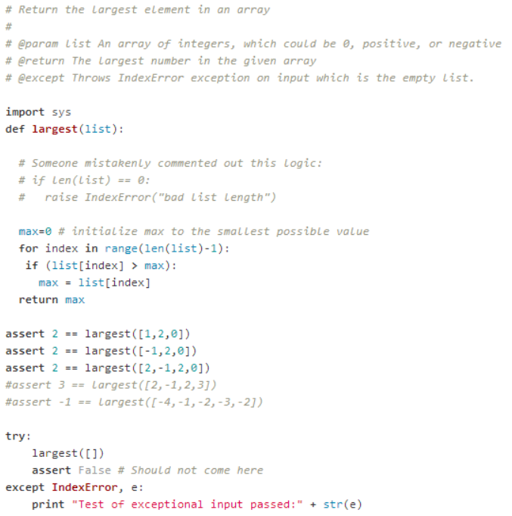

**Step 1:** Run the code using IPython debugger

**%run –d Mini_HW4.py**

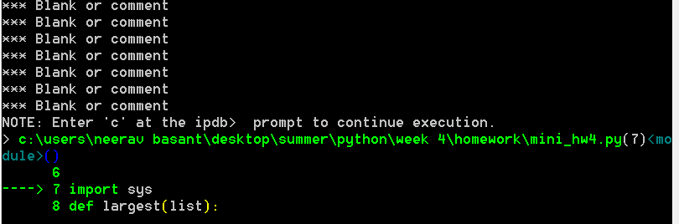

**Step 2:** We will set the break points at all the assert statements and make sure we pass all the test cases by correcting the code. We will also uncomment the two test cases (assert statements) that are currently commented.

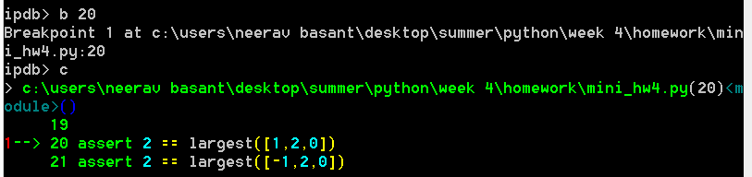

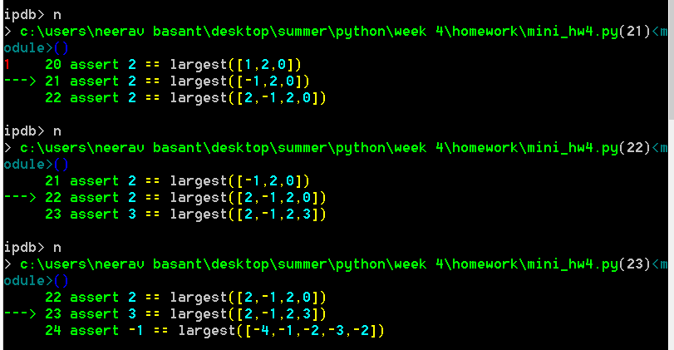

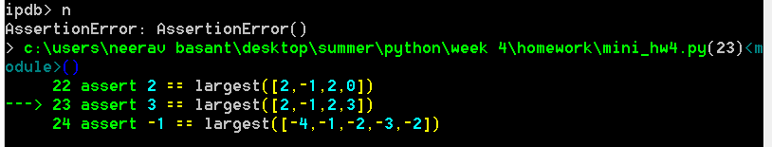

**Step 3:** At line 23 we got an assertion error. This error was due to the fact that ‘for’ loop is not including the last element of the list. We can modify the range function and rerun the code.

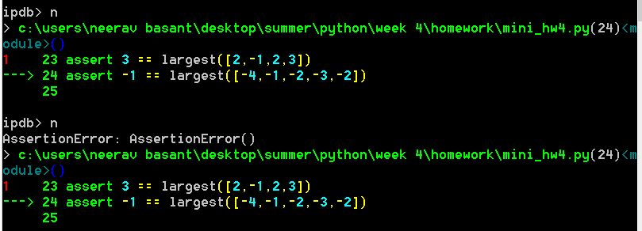

**Step 4:** At line 24 we again got an assertion error. This error was due to the fact that all the elements in the list were negative and we had set the max = 0.

We can modify the code by setting the value of max to the minimum possible integer value i.e. **max = - sys.maxint -1**

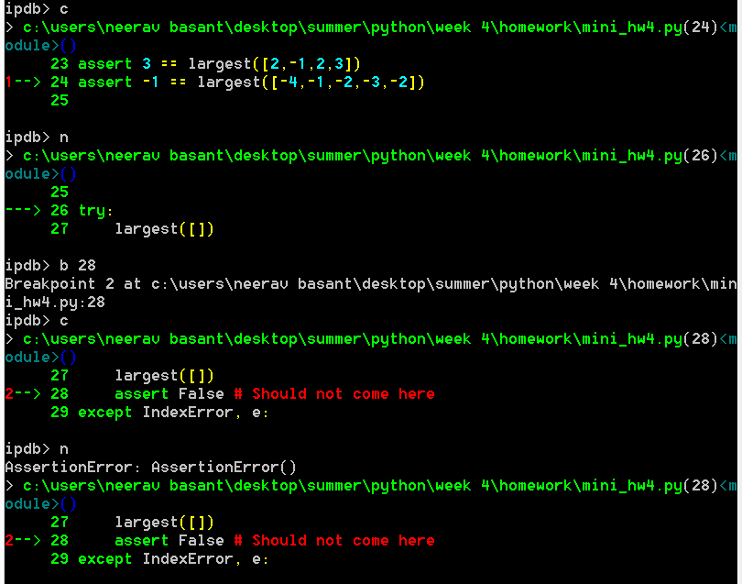

**Step 5:** At line 28 we got an error. This was due to the fact that we are passing an empty list and the asserting false. If we don’t want to run the start statement, we need to catch this exception before that statement runs. But unfortunately, the code that was supposed to perform this function (line 11 -12) is commented. We will uncomment that part of the code and run the whole code again.

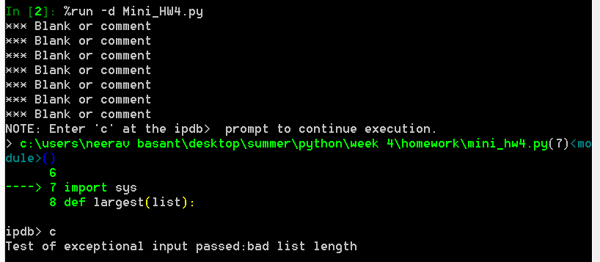

**Step 6:** Since the code ran without error and exited the debugger, we have debugged the code completely. Please find below the updated code:

